**Bug Summary Report of** **Dvago**

**Bug Name:** Selected filter is undo when select more filter.  
**Bug ID:** DVG-01  
**Area Path:** dvago.pk -> collections -> baby-care (https://dvago.pk/collections/baby-care)

**Build Number:** Version Number 5.0.1  
**Severity:** High

**Priority:** High  
**Assigned to:** XYZ  
**Reported By:** Ayesha  
**Reported On:** 12/22/2022  
**Reason:** Defect  
**Status:** New   
**Environment:** Windows 10/ Chrome Browser

**Description:**If user select one filter & want to select more filter, already selected filter shouldn’t be unselect or uncheck.

**Steps to Reproduce:**

1. Go to dvago.pk
2. Navigate to the dvago.pk -> collections -> baby-care
3. Select one check box/filter
4. Select one check box/filter

**Expected Result:** on clicking another checkbox/filter, second filter should be selected.

**PFA Screenshot**

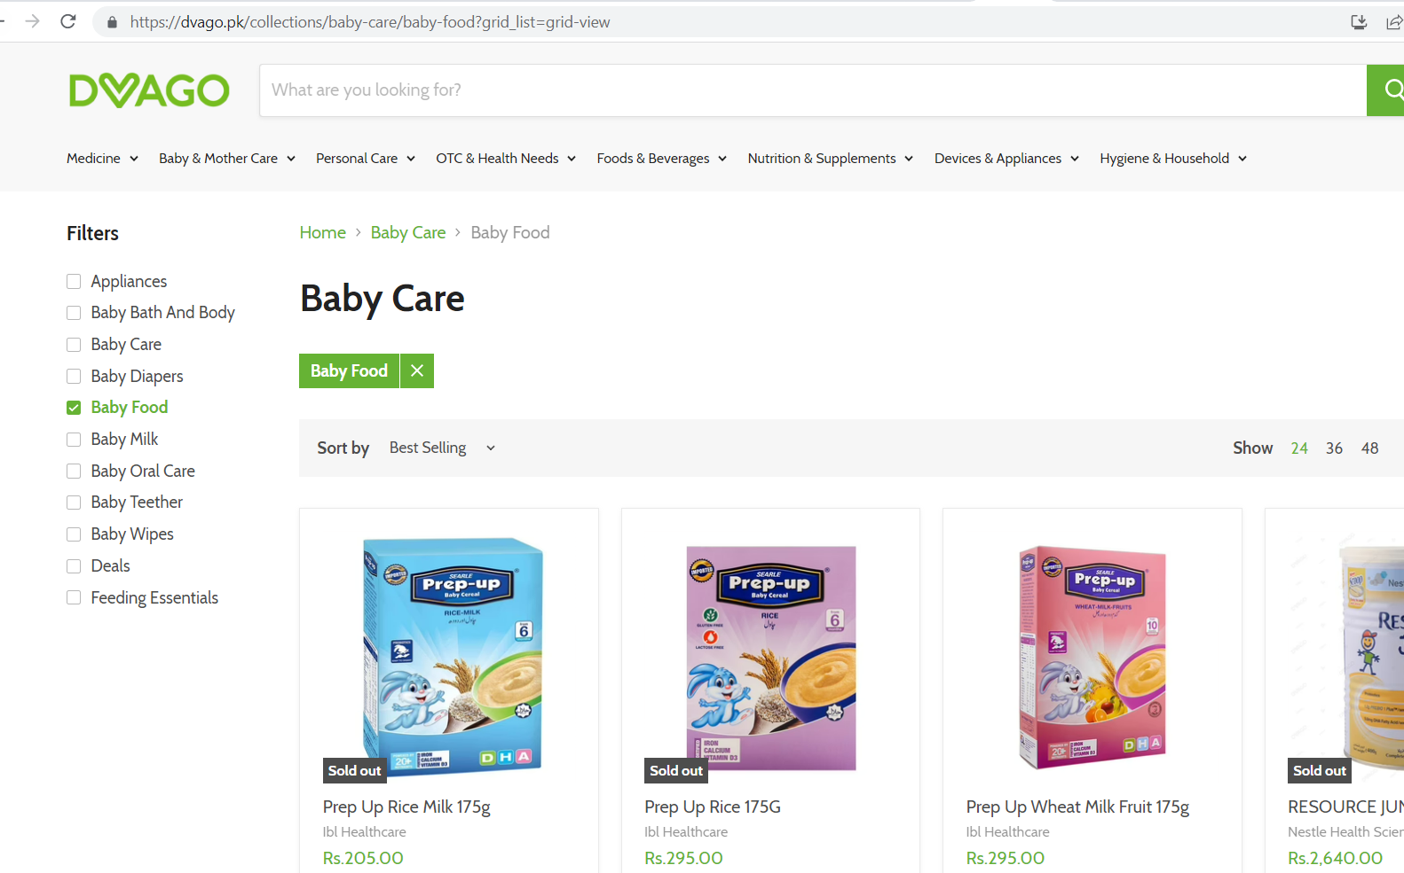

**Bug Name:** Buttons alignment should be properly

**Bug ID:** DVG-02  
**Area Path:** dvago.pk -> collections -> baby-care -> Add product in cart-> popup appears

**Build Number:** Version Number 5.0.1  
**Severity:** Low

**Priority:** High  
**Assigned to:** XYZ  
**Reported By:** Ayesha  
**Reported On:** 12/22/2022  
**Reason:** Defect  
**Status:** New   
**Environment:** Windows 10/ Chrome Browser

**Description:**If user add product in cart, buttons should be properly aligned in popup.

**Steps to Reproduce:**

1. Go to dvago.pk
2. Navigate to the dvago.pk -> collections -> baby-care
3. Add product in cart
4. Popup appears

**Expected Result:** Buttons should be properly aligned.

**PFA Screenshot**

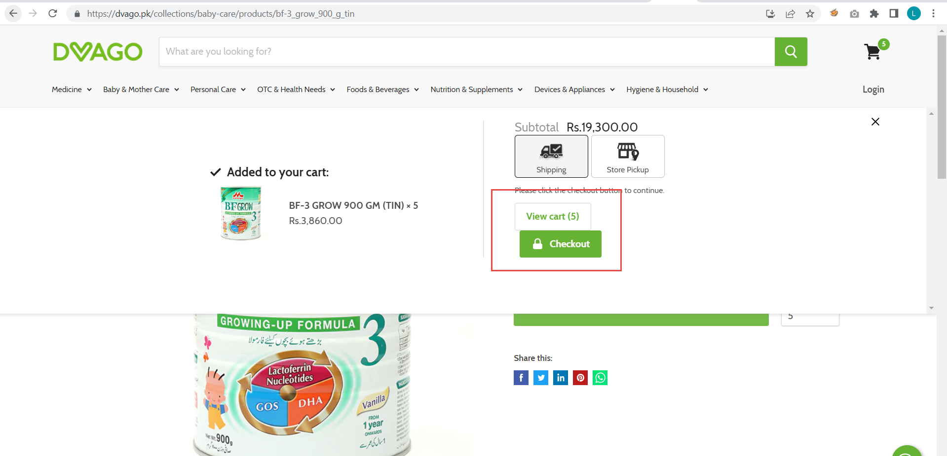

**Bug Name:** Unable to search address

**Bug ID:** DVG-03  
**Area Path:** dvago.pk -> collections -> baby-care -> Add product in cart-> go to cart (https://dvago.pk/cart)

**Build Number:** Version Number 5.0.1  
**Severity:** High

**Priority:** Medium  
**Assigned to:** XYZ  
**Reported By:** Ayesha  
**Reported On:** 12/22/2022  
**Reason:** Defect  
**Status:** New   
**Environment:** Windows 10/ Chrome Browser

**Description:**If user want to add address for store pickup, user unable to search address in address search bar. (Error appears: This page can’t load)

**Steps to Reproduce:**

1. Go to dvago.pk
2. Navigate to the dvago.pk -> collections -> baby-care
3. Add product in cart
4. Select Store Pickup
5. Enter address in search bar

**Expected Result:** Address should be search

**PFA Screenshot**

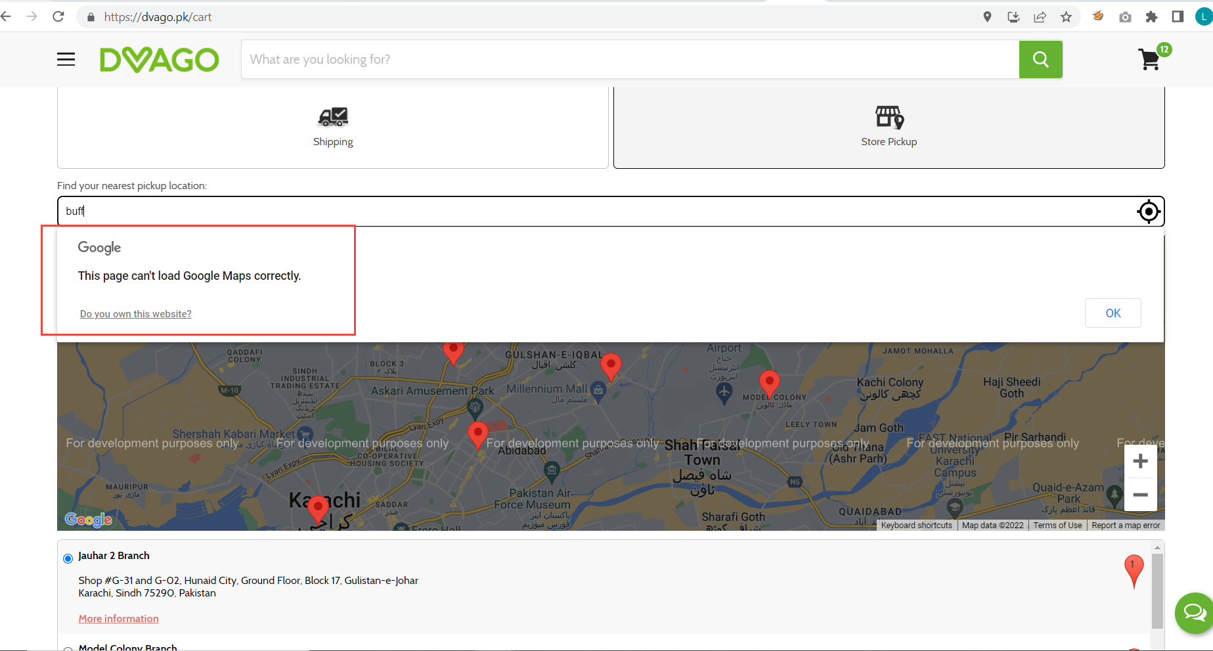

**Bug Name:** Unable to add date/time

**Bug ID:** DVG-04  
**Area Path:** dvago.pk -> collections -> baby-care -> Add product in cart-> go to cart (https://dvago.pk/cart)

**Build Number:** Version Number 5.0.1  
**Severity:** High

**Priority:** Medium  
**Assigned to:** XYZ  
**Reported By:** Ayesha  
**Reported On:** 12/22/2022  
**Reason:** Defect  
**Status:** New   
**Environment:** Windows 10/ Chrome Browser

**Description:**If user want to add date/time for store pickup, date picker becomes gray when select date/time.

**Steps to Reproduce:**

1. Go to dvago.pk
2. Navigate to the dvago.pk -> collections -> baby-care
3. Add product in cart
4. Select Store Pickup
5. Select date & time

**Expected Result:** User should be able to select date/time properly

**PFA Screenshot**

